**Designing a 100 watt boost converter for a Led flashlight**

|  |  |
| --- | --- |
| Author | Bram Vanderwegen |

Content

1 Introduction 2

2 Material and Methods 2

2.1 Description circuit 2

2.2 Description casing 3

2.3 Bill of materials 4

2.4 Designing process 6

2.4.1 Designing the schematic 6

2.4.2 Designing the PCB 6

2.4.3 Designing the casing 6

2.4.4 Ordering the PCB 7

2.4.5 Manufacturing the casing 7

2.5 Construction 7

2.5.1 PCB construction 7

2.5.2 Programming the PCB 7

2.5.3 Final assembly and construction of the casing 7

3 Results 7

3.1 General overview 7

3.1.1 Setup 7

3.1.2 Working principle 7

3.2 Design images 8

3.2.1 Schematic 8

3.2.2 PCB 8

3.2.3 Mechanical design 9

4 Discussion 9

5 Reference list 10

# Introduction

This paper covers the designing process of a 100W 12V to 36V boost converter.

Led flashlight are commonly restrained in light output for use in common situations, This makes them manageable in terms of power supply which usually consists of a number of batteries in series. However, for more specialized occasions, more powerful flashlight are required. Aside from the increase in power of the LED modules themselves, the power supply must also be adapted to the increase in power.

Often the LED modules will have a higher voltage drop to reduce losses from resistance. This poses a problem for most batteries have a significantly lower voltage potential. Putting multiple in series to increase the voltage would be unfeasible due to the high current. This is why a boost converter is utilized to step up the voltage.

A boost converter steps up the voltage by charging an inductor and discharging it at high speeds. Because of the property of an inductor the voltage will be increased while discharging.

Firstly, the materials and design process is covered, followed by the end result of the boost converter. The final part deals with difficulties encountered during the design process.

# Material and Methods

To design this device three main materials were used: software, tools and components.

In terms of software Altium design, AutoCAD and AVRDUDESS were used.

Altium design was used to design the schematic and the PCB. It has a wide assortment of tools to use which are well documented online. Furthermore Altium design has an integrated library where the footprint of a component is directly linked to the schematic symbol for ease of placement in the PCB design stage.

The casing was designed in AutoCAD as it had all the tools necessary to design accurately and efficiently.

AVRDUDESS was used to program a hex file using an external programmer to the microcontroller.

The machines used are a reflow oven and a laser cutter.

The tools used are a soldering iron, pliers, tweezers and wire cutters.

## Description circuit

The components used were chosen based mainly on the availability and pricing. SMD technology was prioritized over THT to reduce the size of the print. The SMD resistors and capacitors were chosen to be size 0805 for ease of soldering.

The schematic on which this PCB is based was published in the July 2013 Elektor issue.

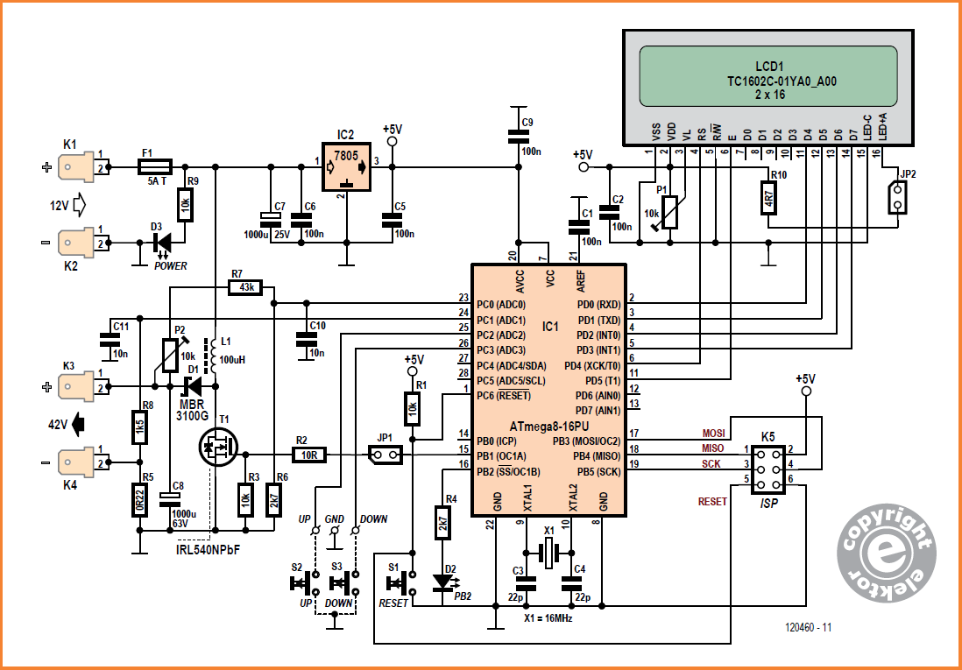

Fig. 1 Schematic from Elektor

This schematic is capable of stepping up a voltage of 8V to 16V up to a maximum of 42V with a limit of about 1A. Furthermore, it has an LCD screen to display the current value. [1]

However, to get sufficient power to drive the LED about 3A is needed. For that reason a few components were replaced with equivalent components that have higher power ratings. Notably the inductor L1, the diode D1 and the shunt resistor R5. The diode D1 was changed from a MBR3100G to a DSS 16-01A. [2] Furthermore a few edits were made on the input and output connections to better suit the application. The terminals K1 through K4 were changed to two screw terminals and the K5 terminal to a 2X3 male pin header.

## Description casing

The purpose of the casing is to protect the PCB and allow it to function properly. It is made out of 6mm MDF with support from steel reinforcement and screws. The casing has a box-like shape with a handle on top. Inside the box there are two main compartments: the battery area and the PCB area. The battery area exclusively contains the battery. This way the it is tightly secured and unable to slide causing weight imbalances. The PCB area is in front of the battery area. This compartment houses the PCB itself, a cooling fan and multiple heat sinks for the high power components. Furthermore, this area contains multiple holes to ensure airflow generated by the cooling fan. The space in front of the PCB area is primarily occupied by a large heatsink on which the power LED is mounted.

## Bill of materials

The materials were mainly sourced from Reichelt as it was the most reliable supplier at the time. Some more specific components were sourced from Würth Elektronik as only they had certain specific components. They also had clear documentation and Altium design libraries available for every component.

The replacements for certain parts were found by looking up similar parts in a web browser and reviewing datasheet for if they met the updated requirements.

## Designing process

### Designing the schematic

The schematic was designed in Altium Designer. It was build based on the Elektor schematic using components sourced from either the internal Altium libraries or external libraries. By doing this, the bill of materials was automatically generated by the software.

### Designing the PCB

The PCB was designed in Altium Designer as well. The software allows the components to be dragged from a side area and to be placed on the PCB. The only remaining thing to do was to make electrical connections using copper traces and vias. The software had the option to execute a rule check to check if everything was connected and if everything was in line with the PCB manufacturer’s limitation. The copper trace width could be changed to allow for more current.

### Designing the casing

The casing was designed using AutoCAD. First, a 3D object of the casing and the components was made. This gave a visual way of checking the dimensions and to make sure everything fitted. Based on this 3D model a 2D drawing of every side was made. An important aspect of the laser cuts were the box joints. These are patterns of alternating protrusions and gap which can be fitted together to make a sturdy connection. The dimensions of these gaps and protrusions were 6mm. this corresponds to the thickness of the board from which the sides were cut.

### Ordering the PCB

The PCB was ordered from JLCPCB. First the Gerber files needed to be uploaded and then the order needed to be placed. The price with solder mask included amounted to €9.11. It was shipped at the highest priority which costed about €70.

### Manufacturing the casing

The casing was manufactured at the PXL Makerspace. Its base material were two 600mm x 30mm x 6mm MDF boards. It was cut to shape using a laser cutter.

## Construction

### PCB construction

First the SMD parts were soldered. This was done by applying solder paste with the help of a solder screen to the right pads on the PCB. Then the SMD components were placed on these pads using tweezers. To solder the components, the PCB was heated in the reflow oven. Once the SMD components were soldered the larger THT components were soldered by hand to the PCB.

### Programming the PCB

The ATmega8-16 microcontroller was programmed using a hex file included in the Elektor issue. This was done with the SPI protocol. An Arduino UNO was programmed to serve as the programmer and was connected to the right pins to access the microcontroller on the PCB. AVRDUDDESS was used to program the hex file via the Arduino to the Atmega8-16.

### Final assembly and construction of the casing

The casing was test-fitted before it was glued together. During this phase files were used to enlarge any holes to make sure everything fitted. Holes were drilled to fasten the heatsinks to the casing. All the electrical connections between the LED, the power switch and battery were made.

Following this, the casing was built procedurally to include the battery and the PCB which would be hard or impossible to access after the casing was complete. To make the connection between all the parts a combination of wood adhesive and screws were used.

# Results

## General overview

### Setup

The switch needs to be flipped to connect it to the battery and thus provide a voltage source. Then the microcontroller will slowly let the voltage rise to about 21V. From here the voltage can be set using SW1 and SW2. To enter current limiting mode both SW1 and SW2 need to be pressed at the same time. The LCD screen display the voltage and the current limit.

### Working principle

When power is applied, the Atmega8-16 microcontroller will send a PWM signal to the MOSFET, rapidly switching it on and off. When the MOSFET is on a current will flow through the inductor charging it by creating a magnetic field, when the MOSFET switches off the magnetic field collapses and the inductors releases its energy through the output at an increased voltage. This voltage is measured using the P2-R7-R6 voltage divider and fed back to the microcontroller. Using this information, the microcontroller can accurately alter the PWM duty cycle to change the voltage. At the end of the output there is a current shunt which also feeds back into the microcontroller which can use this to change the PWM duty-cycle and limit the current. P1 can be used to change the contrast on the LCD.

## Design images

### Schematic

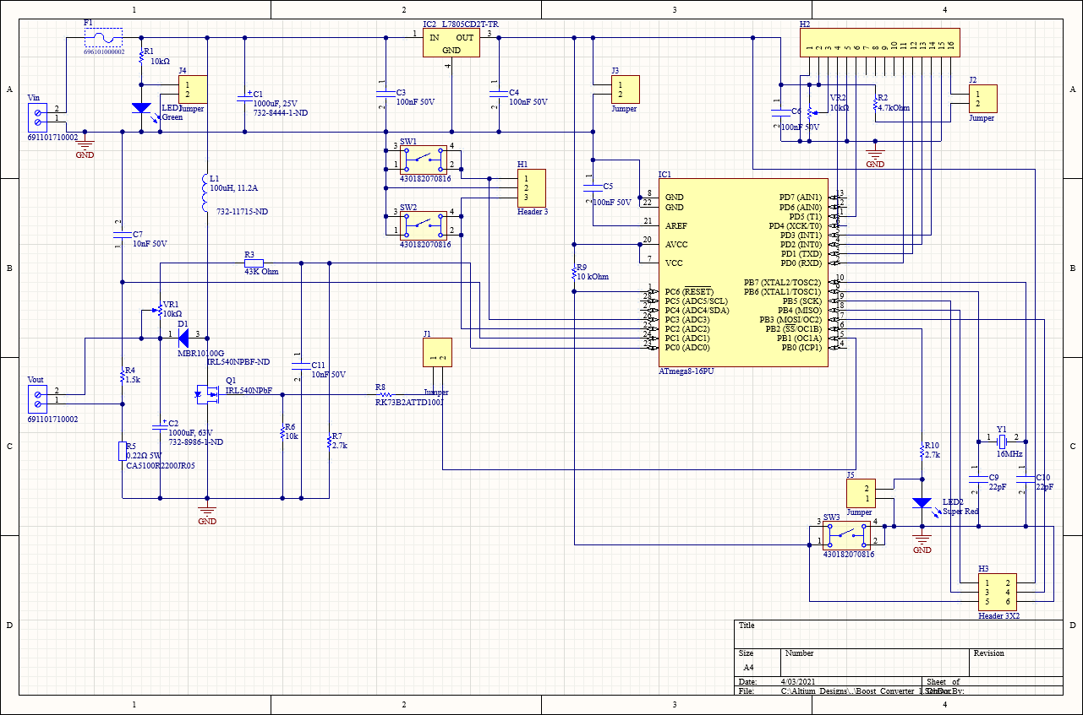

Fig. 2 Schematic in Altium Designer

### PCB

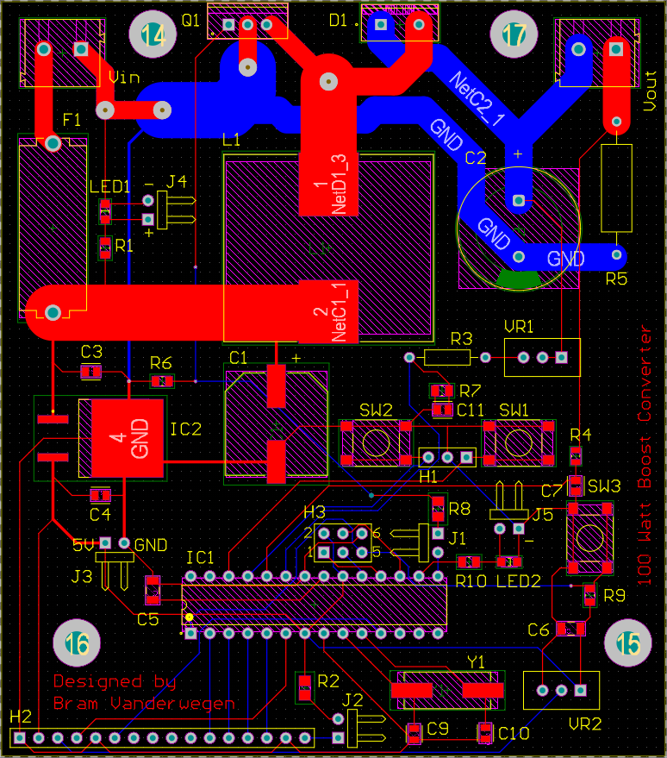

Fig. 4 PCB layout in Altium Designer Fig. 4.2 PCB

### Mechanical design

Fig. 5 The mechanical design

# Discussion

The design process went fluently, however, one part, the trimmer potentiometer did not have a footprint available. A custom one was made here. The shape was a simple rectangle so it was not difficult to make.

Some of the traces on the PCB had to be capable of supplying up to 10A. By calculating the required width would be around 300 mils [3] however, this would pose a problem, because the spacing around the input terminals and the switching MOSFET is 100 mils to 200 mils. Therefore, two parallel traces on each side of the board were used with a width of 100 mils which made each of them capable of supplying 4.7A. [3] These parallel connections were then reconnected to a wider trace using vias.

During the testing procedure an error was found. This error occurred when the 12V would be applied to the input causing the fuse to blow. Measuring the resistance between the input and the ground gave no indication of a short-circuit. A lab bench power supply with current limiting function was used to check for any voltage drops to find the defect component. Between the input and ground a voltage drop of about 0,7V was measured. This indicated a diode-like component caused the short circuit. This also explains why the resistance measurement returned nothing as the current only started flowing when the voltage reached 0.7V. Going on this information, It was determined the only diode in this net was the MOSFET’s flyback diode. This would mean the MOSFET’s drain and source were reversed. After removing the MOSFET the voltage drop across the input and ground became the desired 12V and the power-indicating lit up. After reconnecting the MOSFET with the drain and source now correctly connected the circuit worked properly.

# Reference list

|  |  |
| --- | --- |
| [1] | W. Schmidt, „PWM-boost-converter,” *Elektor,* nr. 4, pp. 108-111, 2013. |
| [2] | „DSS 16-01A,” IXYS, [Online]. Available: https://ixapps.ixys.com/DataSheet/L137.pdf. [Geopend 04 04 2021]. |
| [3] | „PCB Trace width calculator,” Advanced Circuits, [Online]. Available: https://www.4pcb.com/trace-width-calculator.html. [Geopend 04 04 2021]. |